Exercise 4: Creating and Configuring a Maven Project

Scenario:
Set up a new Maven project for the Library Management application and configure it with the required Spring Framework dependencies.

Steps Performed:
- Created a new Maven project named LibraryManagement1.
- Updated the pom.xml file with Spring Context, Spring AOP, Spring WebMVC and AspectJ Weaver dependencies.
- Configured the Maven Compiler Plugin for Java 21.
- Updated Maven dependencies using Maven → Update Project.
- Verified the Java Compiler compliance level.
- Verified that all Spring libraries were downloaded under Maven Dependencies.

pom.xml:
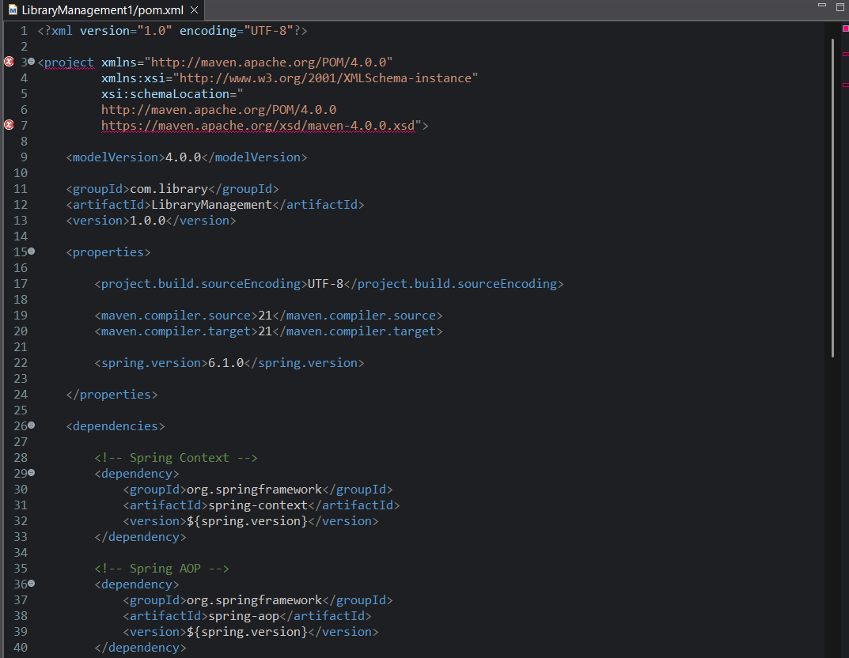
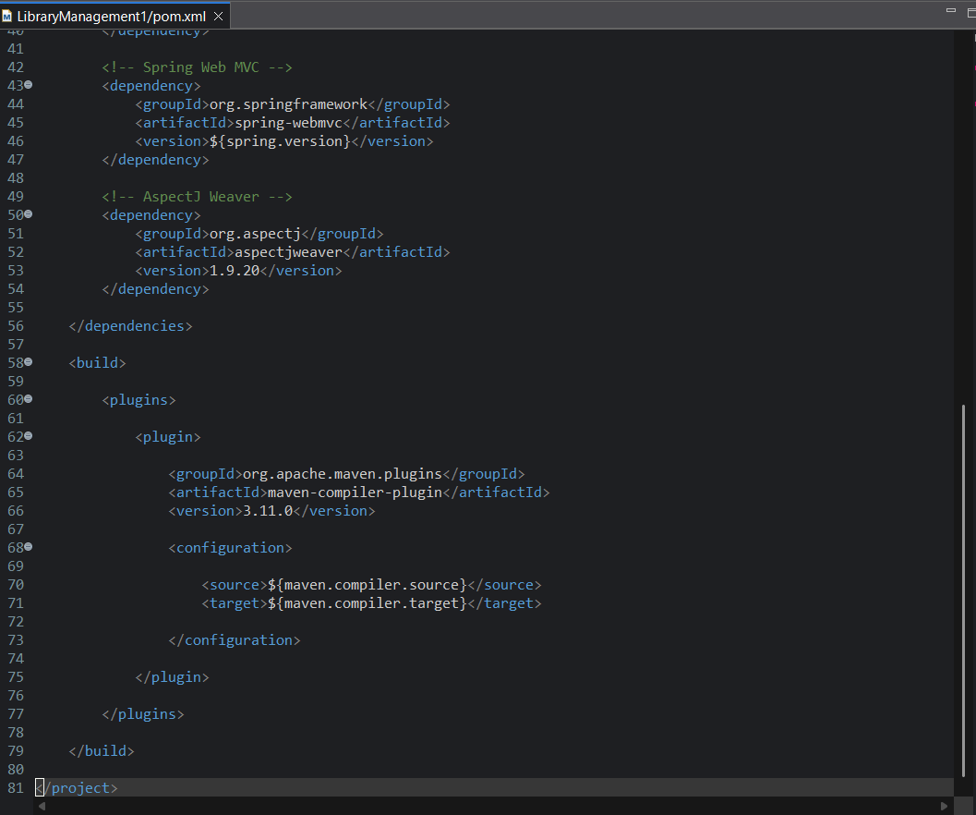

Expected Project Structure:
LibraryManagement1
├── src/main/java
├── src/main/resources
├── src/test/java
├── src/test/resources
├── Maven Dependencies
├── JRE System Library [JavaSE-21]
├── target
└── pom.xml
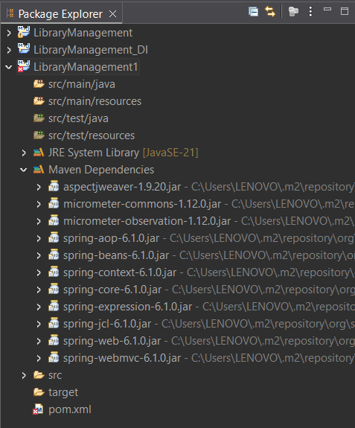

Conclusion:
The Maven project was successfully created and configured for Spring development. The required Spring libraries and compiler plugin were added, making the project ready for future Spring applications.

